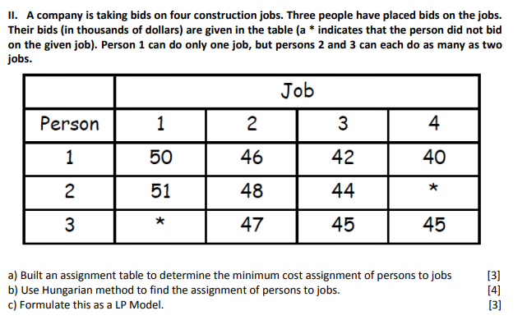

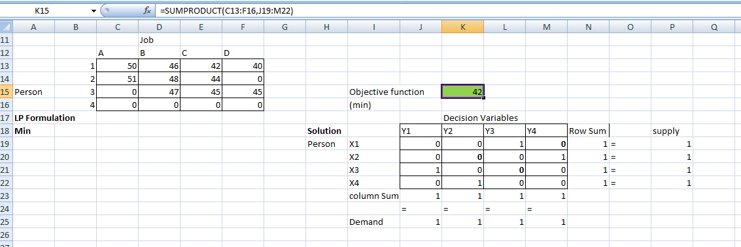

|  |
| --- |
| Problem Formulation : (UnBalanced, So Dummy Row is introduced) i.e 4 Jobs, 4 Persons.  As this is 'Assignment problem', we are taking only one allocation per col/row Min SUMPRODUCT(SUMPRODUCT(C13:F16,J19:M22) s.t. Σ Xi * Y1 <= 1, Σ Xi * Y2 <= 1, Σ Xi * Y3 <= 1, Σ Xi * Y4 <= 1, Σ X1 * Yi = 1, Σ X2 * Yi = 1, Σ X3 * Yi = 1, Σ X4 * Yi = 1,  (i = 1,2,3,4) Optimal Cost : 42 |
|
|
|
|
|
|
|
|